**Homework 4**

**ESE – 3025**

**EMBEDDED REAL TIME OPERATING**

**SYSTEMS**

Submitted to :

Proff. Takis Zourntos

Submitted by:

Gurvinder Singh(748418)

**1. Download IDE and cross toolchain from the NXP web site:**

Creating account:

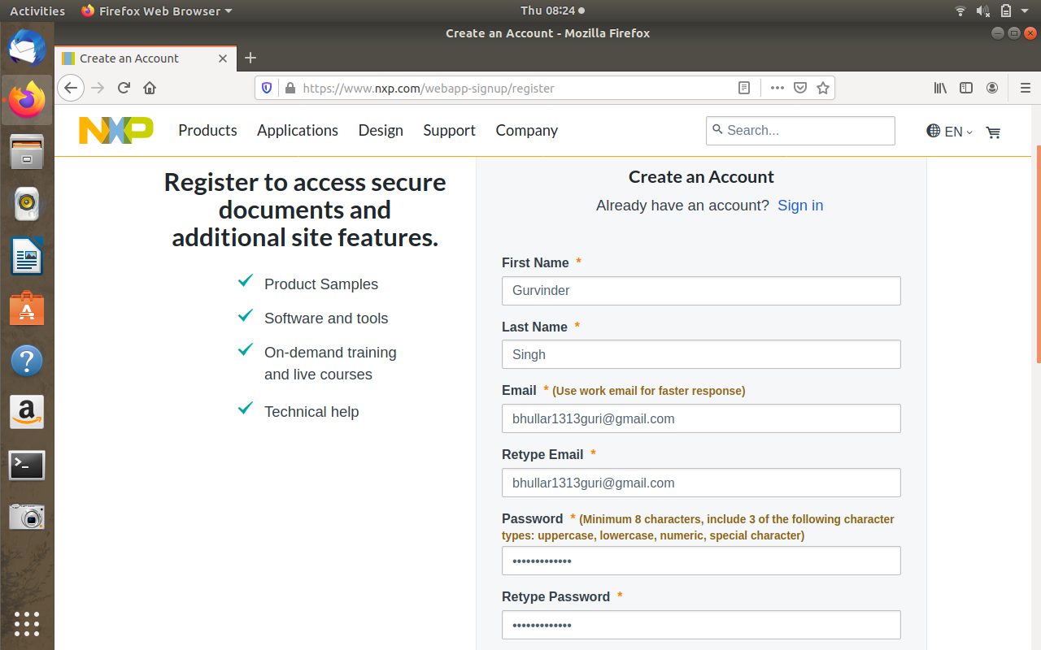

Changing the permissions to run the file:

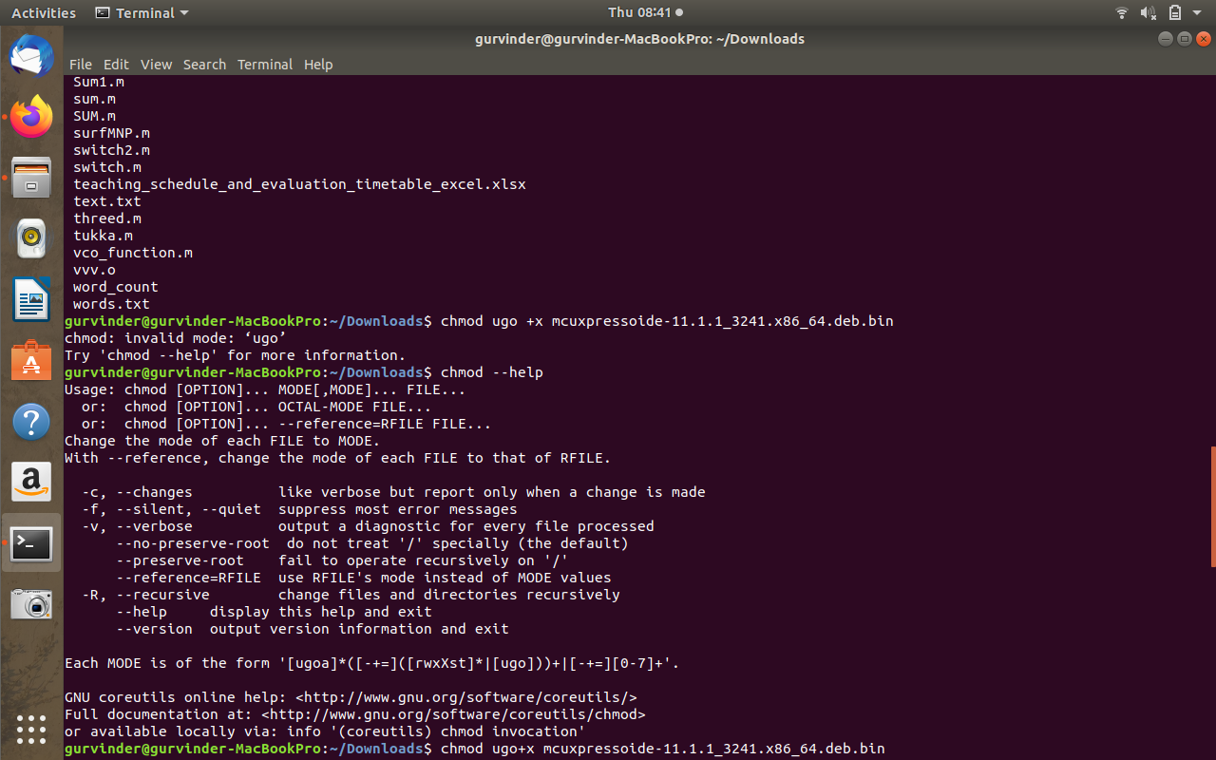

Running the file:

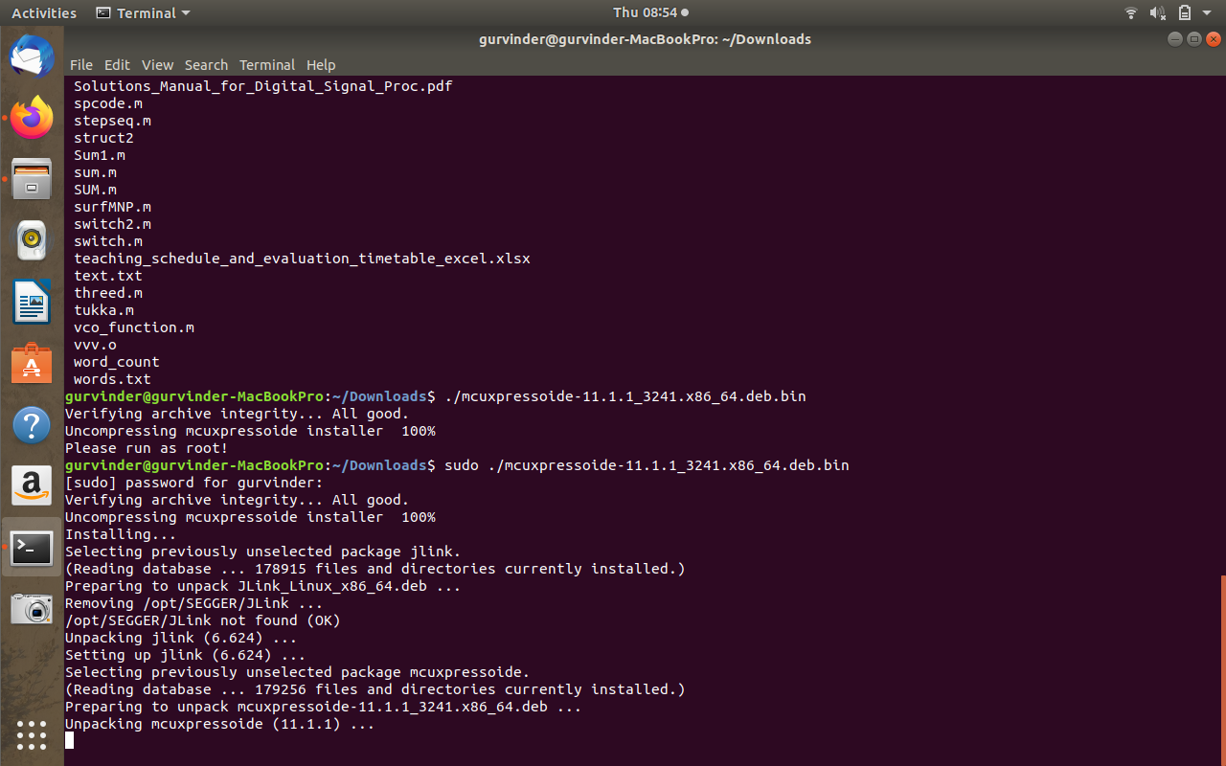

Launching the software:

